January 29, 2021
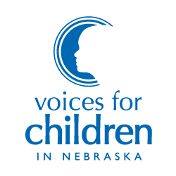
7521 Main Street, Suite 103 Omaha, Nebraska 68127

(402) 597-3100
www.voicesforchildren.com

BOARD OF DIRECTORS

Bruce Meyers
President

Amy Boesen
Vice President

Lorraine Chang, JD
Secretary

Michael Beverly, Jr., MBA
Treasurer

Gary Bren
Wes Cole, MBA
Al Davis
Noah Greenwald, JD
Daniel Gutman, JD
Tim Hron, MA, LIMHP
Susan Mayberger, MA
Melanie Morrissey Clark
John Stalnaker, JD
Charlie Stephan
Katie Weitz, PhD

Aubrey Mancuso, MSW
Executive DIrector

To: Chairperson Lathrop and Members of the Judiciary Committee
From: Taylor Givens-Dunn, Voices for Children in Nebraska
Re: LB 97 – Change provisions relating to adoptions

All children deserve to know that their relationships with both of their parents are stable and legally recognized, regardless of their parents’ marital status or sexual orientation. Voices for Children in Nebraska supports LB 97, which would provide for two unmarried adults to jointly adopt and would also clarify current provisions to allow a second parent to adopt without the first parent losing his or her parental rights to the adopted child. This bill would both protect children and grant families important protections under the law.

LB 97 has the potential to provide permanency for a greater number of Nebraska children. Permanent and loving family relationships are essential in ensuring that children become happy and healthy adults, and adoption is always the preferred option to the prospect of having a child “age out” of the foster care system. The average time to adoption after a termination of parental rights in juvenile court was 10.1 months in 2019, and older youth and children of color linger longer in foster care. With more than 800 of Nebraska’s children waiting for adoption, LB 97 has the potential to bring more children in care into a permanent and loving home.

Children in a co-parent home need the permanence and security that are provided by having two legally recognized parents. The legal sanctioning of second-parent adoptions with non-gendered statutory language will serve multiple functions, including: ensuring children will be eligible for health care benefits from both parents and permitting either parent to provide consent for medical treatment (if the child requires timely attention and the biological or adoptive parent is otherwise unavailable to give consent). LB 97 will also ensure that children retain the right to continue the parent-child relationship with the co-parent, should the first parent die or become incapacitated. In the absence of second-parent adoption legislation, the family of the biological/adoptive parent can challenge the surviving co-parent’s rights to raise the children, thus causing children to effectively lose both parents.

LB 97 can create a basis for financial security for children in co-parented homes. The passage of LB 97 would protect the second parent’s right to visit and retain a familial bond with the child, regardless of whether the partners remain together.

Under present law, at the dissolution of a marriage or relationship, the biological/adoptive parent can sever all ties between the child and co-parent and the co-parent is not responsible for the child’s maintenance. Legally recognizing both parents’ responsibility to the children ensures eligibility to federal entitlements such as Social Security and inheritance benefits upon the death of either parent, as co-parents cannot leave federal benefits to children not legally recognized as their own and the children will be taxed on inheritances left by their co-parents as though such inheritances were bequeaths from strangers.

I would like to thank Senator DeBoer for her leadership in protecting child and family well-being and this committee for your time and consideration. Voices for Children would respectfully urge you to advance LB 97.

Sincerely,
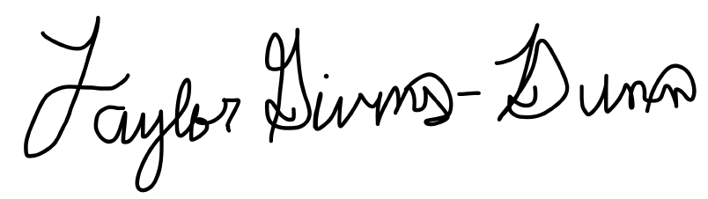
Taylor Givens-Dunn
Policy Coordinator for Child Welfare & Juvenile Justice

Data provided by the Nebraska Department of Health and Human Services.
Adopt US Kids, Information on Nebraska’s Waiting Children.
Fenton, L.M. and Fenton, A., “The Changing Landscape of Second Parent Adoptions”, American Bar Association: Children’s Rights
Hagan, J.F. et al, “Co-Parent or Second Parent Adoption by Same-Sex Parents”, Pediatrics: Official Journal of the American Academy of Pediatrics. 125(2): e444 (2010), doi:10.1542/peds.2009-3160
Beekman, J., “Same Sex Parent Adoption and Intestacy Law: Applying the Sharon S. Model of “Simultaneous” Adoption to Parent—Child Provisions of the Uniform Probate Code,” Cornell Law Review, 96, 1 (2010):139

