February 10, 2021
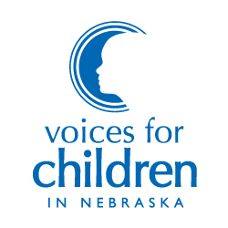
7521 Main Street, Suite 103 Omaha, Nebraska 68127

(402) 597-3100
www.voicesforchildren.com

BOARD OF DIRECTORS

Bruce Meyers
President

Amy Boesen
Vice President

Lorraine Chang, JD
Secretary

Michael Beverly, Jr., MBA
Treasurer

Gary Bren
Wes Cole, MBA
Al Davis
Noah Greenwald, JD
Daniel Gutman, JD
Tim Hron, MA, LIMHP
Susan Mayberger, MA
Melanie Morrissey Clark
John Stalnaker, JD
Charlie Stephan
Katie Weitz, PhD

Aubrey Mancuso, MSW
Executive DIrector

Thank you Chairman Arch and Members of the Health and Human Services Committee. My name is Julie Erickson and I am representing Voices for Children in Nebraska in support of LB 677.

LB 677 increases eligibility for transitional child care, or child care provided to those who are already participating in the child care subsidy program. This helps ensure a more gradual transition to affording the full cost of child care without assistance. The Legislature has made several improvements to ongoing eligibility for child care assistance in recent years and LB 677 takes it a step further by increasing ongoing eligibility to 200% of the federal poverty line, currently around $52,000 annually for a family of four.

Increasing ongoing eligibility for child care ensures that working parents can seek higher paying jobs while still being able to afford the high cost of care. We urge the committee to advance LB 677. Thank you.

