February 4, 2021
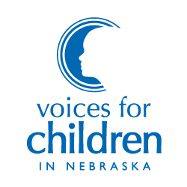
7521 Main Street, Suite 103 Omaha, Nebraska 68127

(402) 597-3100
www.voicesforchildren.com

BOARD OF DIRECTORS

Bruce Meyers
President

Amy Boesen
Vice President

Lorraine Chang, JD
Secretary

Michael Beverly, Jr., MBA
Treasurer

Gary Bren
Wes Cole, MBA
Al Davis
Noah Greenwald, JD
Daniel Gutman, JD
Tim Hron, MA, LIMHP
Susan Mayberger, MA
Melanie Morrissey Clark
John Stalnaker, JD
Charlie Stephan
Katie Weitz, PhD

Aubrey Mancuso, MSW
Executive DIrector

To: Members of the Health and Human Services Committee
From: Aubrey Mancuso, Executive Director
Re: Support for LB 447 relating to immunizations for licensed child care programs

Voices for Children supports LB 447 because of the importance of vaccinations for healthy child development. Vaccines are critical to a healthy population and this is especially true for children because disease can interfere with healthy development.

LB 447 ensures that there is a statewide standard for licensed child care in tracking vaccines and ensuring that exceptions are medically necessary. The COVID-19 pandemic illustrated how devastating a lack of vaccines can be. Not only have thousands of Nebraskans lost their lives, but the economy and businesses across the state have been significantly impacted.

LB 447 helps ensure that our children in our licensed child care facilities are vaccinated except when there is a medical exception and ensures that information is uniformly tracked. We urge the committee to advance this bill. Thank you.

